Day 7

**C++ Inheritance**

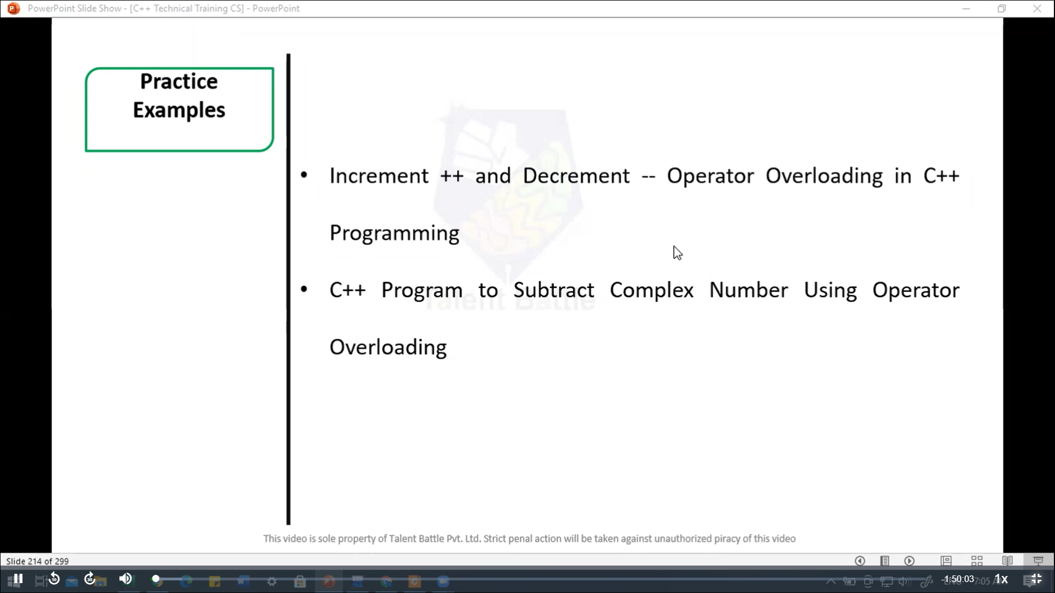

#include <iostream>

using namespace ***std***;

*class* MyClass {

  private***:***

    int value;

  public***:***

*MyClass*() ***:*** *value*(0){}

    // Prefic increment

    MyClass& operator***++***(){

      ++value;

      return *this;

    }

    // Postfix increment

    MyClass operator***++*** (int){

      MyClass temp = *this;

      ++value;

      return temp;

    }

    // Prefix decrement

    MyClass& operator***--*** (){

      --value;

      return *this;

    }

    // Postfix decrement

    MyClass operator***--***(int){

      MyClass temp = *this;

      --value;

      return temp;

    }

    void *display*() const {

       cout ***<<*** "Value: " ***<<*** value ***<<*** endl;

    }

};

int *main*(){

  MyClass obj;

  cout ***<<*** "Initial ";

  obj***.****display*();

  cout ***<<*** "After prefix increment ";

  ++obj;

  obj***.****display*();

  cout ***<<*** "After postfix increment ";

  obj++;

  obj***.****display*();

  cout ***<<*** "After prefix decrement ";

  --obj;

  obj***.****display*();

  cout ***<<*** "After postfix decrement ";

  obj--;

  obj***.****display*();

  return 0;

}

/*

Initial Value: 0

After prefix increment Value: 1

After postfix increment Value: 2

After prefix decrement Value: 1

After postfix decrement Value: 0

--------------------------------

Process exited after 0.1404 seconds with return value 0

*/

//======================================================

#include <iostream>

*class* Complex {

private***:***

    double real;

    double imag;

public***:***

    // Constructor

*Complex*(double ***r*** = 0***,*** double ***i*** = 0) ***:*** real(***r***)***,*** imag(***i***) {}

    // Overloading the - operator

    Complex *operator-*(const Complex& ***other***) const {

        return Complex(real - ***other.***real***,*** imag - ***other.***imag);

    }

    // Display function

    void *display*() const {

***std::***cout *<<* real *<<* " + " *<<* imag *<<* "i" *<<* ***std::****endl*;

    }

};

int *main*() {

    double real1***,*** imag1***,*** real2***,*** imag2;

***std::***cout *<<* "Enter real and imaginary part of the first complex number: ";

***std::***cin *>>* real1 *>>* imag1;

***std::***cout *<<* "Enter real and imaginary part of the second complex number: ";

***std::***cin *>>* real2 *>>* imag2;

    Complex c1(real1***,*** imag1);

    Complex c2(real2***,*** imag2);

    Complex c3 = c1 *-* c2;

***std::***cout *<<* "Result of subtraction: ";

    c3***.****display*();

    return 0;

}

/*

Enter real and imaginary part of the first complex number: 4

3

Enter real and imaginary part of the second complex number: 6

5

Result of subtraction: -2 + -2i

--------------------------------

Process exited after 4.799 seconds with return value 0

Press any key to continue . . .

*/